Company Summary
Student’s Name
Institutional Affiliation
Date

Company Summary

Company background
World Acceptance Corporation has its main focus in the subprime market where individuals have limited access to loans mainly in small amounts of loans. The loans offered by the company attract interests of less than $1000 and they mature in less than one year. Also, apart from loans, the company offers insurance for credit and also credits for those who acquire electronic appliances via the World Class Buying Club.
The company began its operation in 1962 with the name World Finance. It provided small loans to consumers in Greenville, South Carolina. Today it operates in more than 470 offices in Oklahoma, Kentucky, Illinois, New Mexico, Alabama, Louisiana, and Missouri. Among the founders of the company is Mr. Jeff L. Tinney. The company underwent some achievements since its founding. First, in 1973, the company acquired World Finance. Secondly, in 1982, it issued loans worth $26 via its numerous offices in Georgia and South Carolina. Thirdly, it merged with First Union Corporation in 1986. Fourthly, in 1991 expanded for profit making. Fifth, the company acquired ParaData Financial for finance software in 1993. Lastly but not least, in 2001 the company saw its loan portfolio increased by 111%.

Resources, facilities, and equipment
The company operates in the service industry by provision of loans to consumers in different locations where its branches are found. The loans are provided to customers and they attract interest. The company realizes its profits through various interests charged on loans given out the customers. In addition, the company owns a fleet of buildings where its various offices are situated in various states. It also boasts of a well-trained team of employees led by the Chief Executive Officer in the various branches. World Acceptance Corporation also uses acquisitions to enrich its business empire.
The main source of finance for the company is interested in various loans. The company attracts a lot of consumer with friendly interests on loans taken. In addition, customers are also given enough interest periods which gives them enough time to repay the loans. Moreover, the interests are low and hence this is a motivation to the customers and hence becomes easier to keep them.

Marketing methods
The company is one of the leading performers in the industries with loans given out amounting to around to 26 billion per annum as in 1982. Also, the sales of the company accumulate to $164.11. The annual sale volume for the company is 263,070 which is an average of 76,558. This is a good amount of sales in this industry. Again, the company has strategies to improve its performance. For instance, the company works with suppliers of electronics by financing customers who want to purchase electronic supplies (Bloomberg, 2019). This, therefore, ensures that they have a continuous supply of customers and hence increased profits.
The company sub-contracts other companies to perform tasks such as ParaData Financial Systems for the acquisition of data. This enables the company to enjoy services of very accurate and valuable financial data. Furthermore, when it comes to the cost of services and product delivery, the company spends a little on this as it has a number of branches in different locations. By doing this, the company brings services and products close to its customers. This, therefore, maximizes their profits. On the other hand, contracts are awarded to different provider basing on what services they are good at. Contracts are also awarded to top-performing contractors in the industry.

Management and Organization
The management team is composed of the president, the senior vice president and the Chief Executive Officer. There are several vice presidents in charge of different departments such as one for Central Division, one for Operations in Mexico and another one for IT solutions. In addition, there are board members and also different committees. In terms of management, the president is the overall manager. Other executives are assigned different department and branches to run. The company has different ranks from the lowest ranked employee to the president at the top. This, therefore, introduces the aspect of chain of command in the company. Currently, the president is Ravin chad Prashad and the CFO is John L. Calmes Jr (Reuters, 2019).
The payment of employees in the company is done according to predetermined scales which were set according to the qualification of the employees. Reviewing the performance of the different employees is done by the human resource officers of the different branches. Attached to the hiring of employees is the level of education. The team is composed of Ph.D. holders, master degrees, bachelor degrees and diploma certificates.
The company has managed to create a good rapport with the local community around its operations. This includes the working provision of employment for local communities and financing other community support programs. Being in the financing industry, its employees are equipped with accounting skills, customer care skills, finance analysis among others that will help the company to operate well in the industry. Consequently, integration of efforts of the president, CEOs, the manager and various agents make the company successful. The company has a financial advisor who is consulted when the need arises. Lastly, there are opportunities for employees to develop themselves through scholarships and different training programs.
Structure
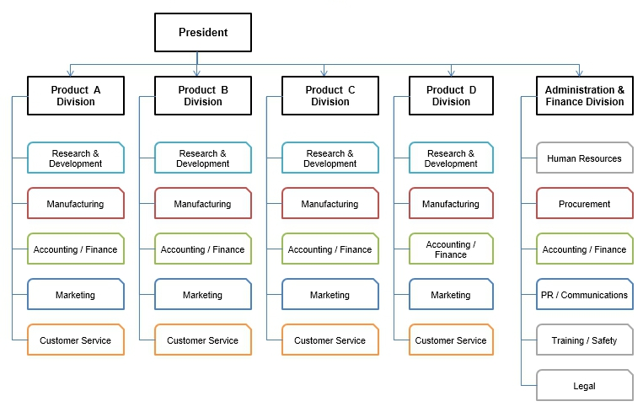

Ownership structure
For the company, the main stakeholders include the shareholders who own different shares in the company. Another set of stakeholders is the partner companies with whom they run certain aspects of the business. Mergers and acquisitions also form stakeholders. In addition, the consumers of products and services of the company are part of the stakeholder.
This company is a corporation which includes inputs of different founding members and also different partnering companies. According to Reuters (2019), the profits are shared between different key founders. Just like any other business, a corporation has to comply with the local and national business operation rules and regulations. These include acquiring business certificates.

Social responsibility
Environmental conservation is an obligation of any business operating either in large or small scale. For that reason, the company has adopted a number of environmentally safe practices such as proper dumping of wastes. Again, chemical waste disposal has been outsourced to the local service providers which ensure that any issue related to chemicals is solved easily. To prevent noise pollution to the surrounding, the company uses machines that are well conditioned.
The organization at large has a great role to play in the community. For instance, the management has the responsibility of ensuring that the activities of the cooperation do not lead to negative effects in the community. It also provides necessary financial help to the community groups. In addition, there are different safeties training programs that the company has put into place. These include training on machines operations and dealing with different chemicals used for various purposes. The training is usually outsourced to experts.

Internal analysis
The firm operates and stays on top of the industry due to presence of a number of strengthen. Some of them include highly skilled employees, distribution to various countries and low interest on loans that attract customers. However, the company has a weakness of supporting only one section of business; the dealers in electronic supplies. In addition, the above general strengths, each individual department is able to run its own activities independently and hence its activities are not interfered with by other departments. The core competence of this company is the low interests of loans as compared to other companies in the industry.
It is important to note that the company is not yet there in terms of its objectives. It also needs some improvement in some areas. One of the crucial areas is improving the working levels. This can be done through capacity building of employees. The company can also increase the number of products it offers to its customers and enhances its diversity. Due to high level of competition, the company should consider strategic locations for easy access by the customers. The existing business units in the company are doing well currently and they, therefore, need improvement. On the other hand, the well-performing unit is that of funding dealers in electronic supplies which gives the company lots of profits in short periods (World Acceptance Corp, 2019).

References
Bloomberg. (2019). Company Overview of World Acceptance Corporation. Consumer Finance.
Retrieved from https://www.bloomberg.com/research/stocks/private/snapshot.asp?privcapId=36697
Reuters. (2019). World Acceptance Corp. retrieved from https://www.reuters.com/finance/stocks/companyProfile/WRLD.O
World Acceptance Corp. (2019). Annual reports. Retrieved from http://www.annualreports.com/Company/world-acceptance-corp

